Mar. 8，2018

Zhang Dali张大力 (b. 1963, Harbin, China)
Solo Exhibition: Monumental Nature
(10 March – 20 May, 2018)

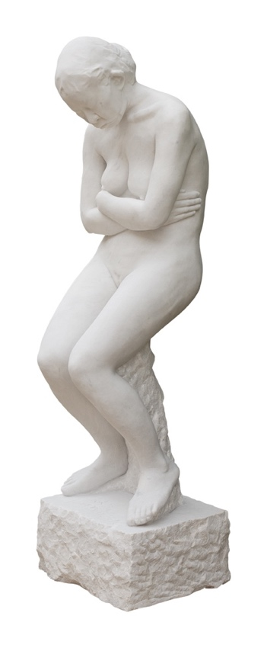
Zhang Dali 张大力，Sculpture, White Marble，146 X 40 x 46 cm, 2016

Press Release

Pékin Fine Arts presents Zhang Dali’s latest cyanotypes and figurative marble sculpture in his 3rd solo exhibition with the gallery. Zhang Dali, China’s most well known graffiti artist, stopped tagging buildings marked for demolition and construction in 2006. However, his deep-rooted connection to urban street life remains very much at the core of his practice.

Economic reality and government policy work together to push city dwellers away from traditional homes at street level into high - rise concrete apartment blocks. Artists including Beijing-based Zhang Dali witness and record this remarkable transformation, with outrage, concern, helplessness, and finally, wry resignation.

Zhang Dali’s practice is research-based, recording daily encounters with the urban space of his living and working neighborhoods on the outskirts of Beijing, surrounded by vacant lots slated for redevelopment. His aim – whether graffiti or cyanotype or marble statuary - is steadily consistent: Immediate contact, unalterable direct impressions of every day life at street level. Using the shadow-subjects of cyanotypes and the full body casts of sculpture-figures, the artist records a rapidly disappearing street life: Depicting the hyper – realist, monumental nature, of urban “survivors” – both human and vegetative - he steadfastly chronicles big city change and traces what remains.

- Beijing, March 2018

For further information, please contact info@pekinfinearts.com or call: (8610) 5127 3220.

