13th Feb, 2014

Yu Likwai (b. 1966, Hong Kong, China)

Pékin Fine Arts: “It's A Bright Guilty World” (22 Feb – 6 April, 2014)

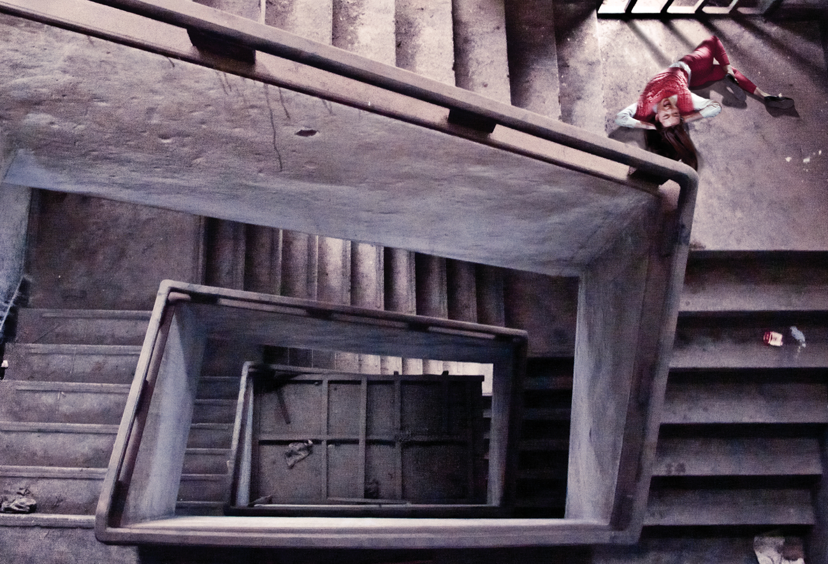
Yu Likwai / Bad Seed No.1 / Giclée print / 75 x 133 cm / 2013

Artist Statement

Yu Lik Wai: It's A Bright Guilty World (chinese title: 无限春光)

It is all about resurrection.
Over years, I have been taking photos of empty spaces: dysfunctional apartments, abandoned factories and urban peripheries. By contemplating these desolate city fabrics, a weird fixation developed in my mind: Is there any possible kind of latent “existence” hidden inside my images? Since then, I was absorbed by the idea of reinventing imaginary human traces belonging to these barren locations.

Thus the whole photographic project was initially a fill in the blank mental exercise. All my narrative motivations were triggered by the Void of these unoccupied spaces even before any human character was invented.

Very soon all kind of overdramatized plots, loosely reconstructed crime scenes, hysterically wild tales of debauchery come up in my mind… And it quickly becomes a question of staging and re-stage, just like what I used to do when we shoot a movie.

Quite inevitably, cinematographic references impose on my storytelling. I am always fascinated by the fatalistic human relationship depicted in Film Noir: the perpetual role-playing game between the victim and the malefactor, the self-victimized and the wrongly accused. After all, Film Noir’s perspective is nihilistic cool. It gives me the carte blanche to reveal the Plausible Impossible, i.e. my fictive “latent image”.

The video installation FLUX is my own reinterpreted Phantasmagoria, an experimental photomontage Frankenstein. The idea originated from some black and white photos that I made 20 years ago. While scrutinizing again these faded pictures, I have a compulsive urge to “reanimate” them, both in spiritual and physical sense.

To endow a freeze frame images with life, montages with different layers of images are projected on transparent holographic film. With low-tech minimalist trompe l'oeil effects, I intend to recreate the sensationalistic visual experience similar to that of an 18th century magic-lantern show.

This installation is also my tribute to silent movies and horror genre. Historically the cinema evinced an affinity with the phantom realm of specters and supernatural beings. Horror emerges as a trope of film itself, as a medium of shadows, dematerialized presence, life drained of substance.

FLUX is an attempt to negotiate dialectics between the freeze frame testimonial nature of photography and the lifelike illusionism of the cinema. As André Bazin explains, cinema is an “idealist” or “essentialist” medium; its illusionism is rooted in the “mummy complex”. In a manner of speaking, this installation is an exercise to reanimate a mummified appearance, revealing my innermost desires and impulses.

For more information, please contact info@pekinfinearts.com or (852) 2177 6190. Thanks!

